

CLOUD COMPUTING
LAB: 06
Submitted By:
Seerat Fatima
Registration.no:
2023-BSE-060
Submitted To:
Engr. Shoaib
Section:
5B

Task 1 – Switch to root with su - and back to a normal user

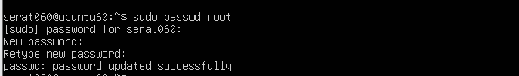
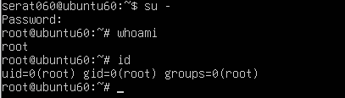
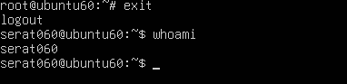

Task 2 – Create user tom and verify in passwd/group/shadow

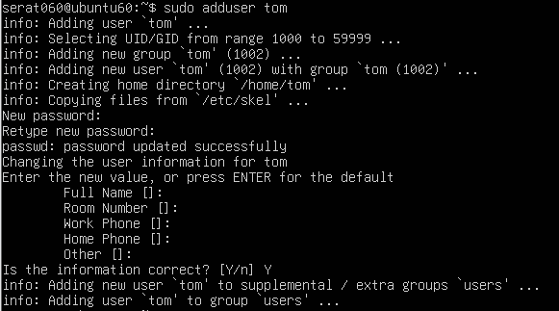
Task 3 – Create groups; change tom’s primary and secondary groups

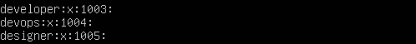
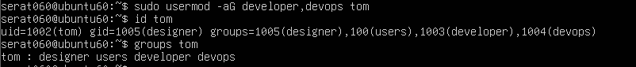
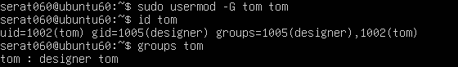

Task 4 – Create/delete users (Jerry, Scooby) and groups (jolly, anime)

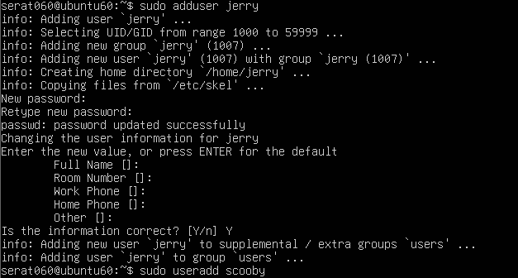
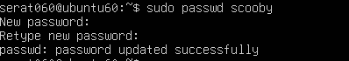
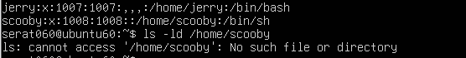
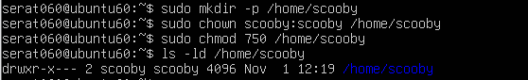
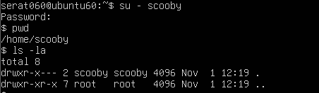
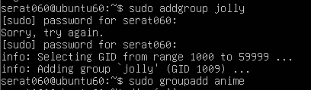

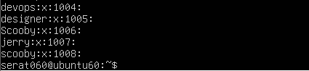
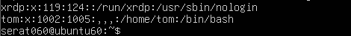

Task 5 – Create user Student; create files; set owner/group; identify file types

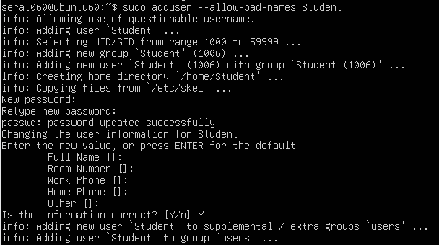
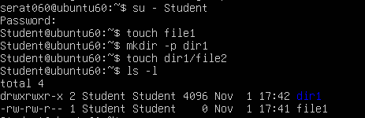
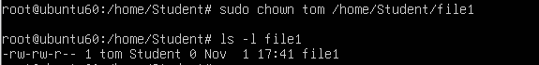
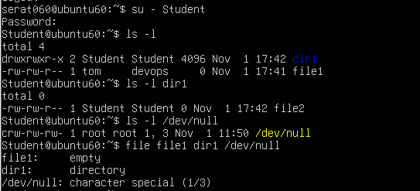
Task 6 – Change permissions using symbolic mode

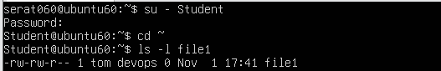
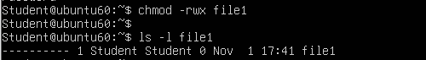
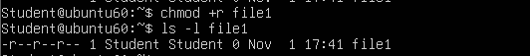
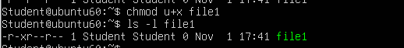
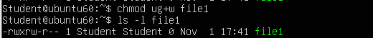


Task 7 – Change permissions using “set” symbolic form (u= g= o=)

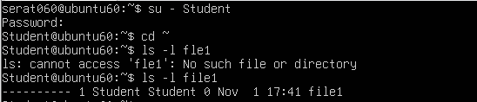


Task 8 – Change permissions using numeric (octal) mode

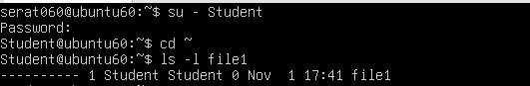

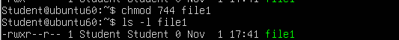

Task 9 – Practice pipes, pagers, grep, and redirects with /var/log/syslog

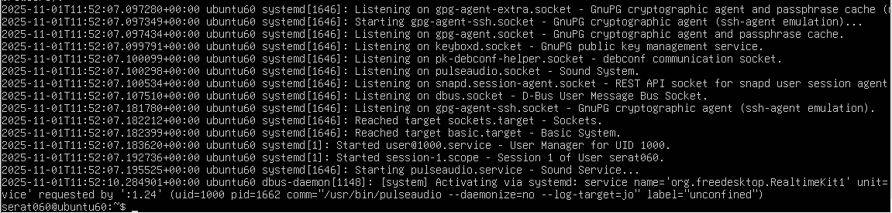
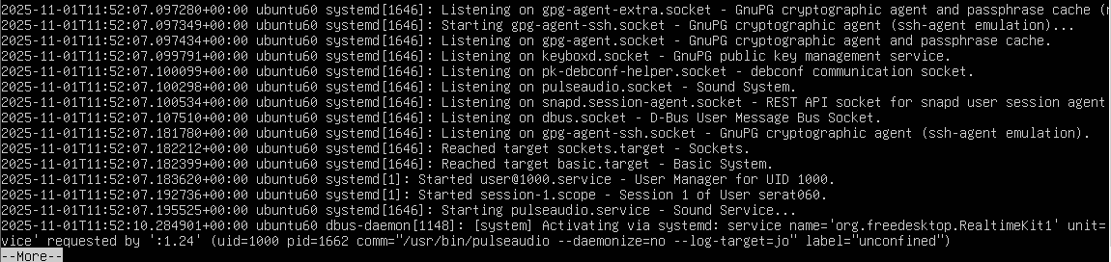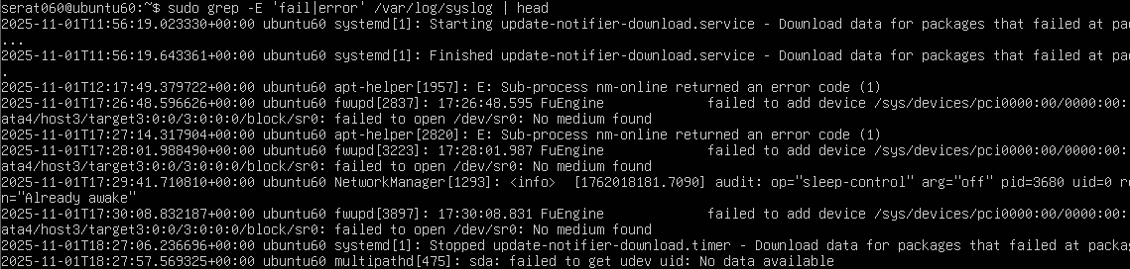
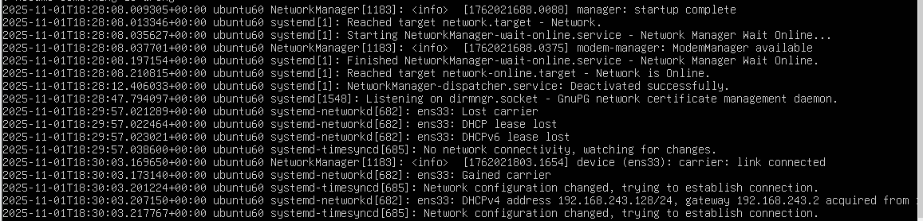

Task 10 – Script setup.sh – variables, command substitution, file/dir checks, permissions (use vim)

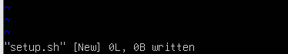
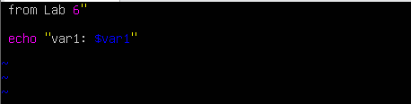
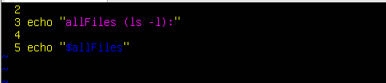
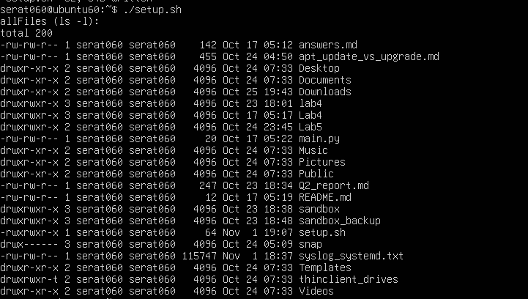
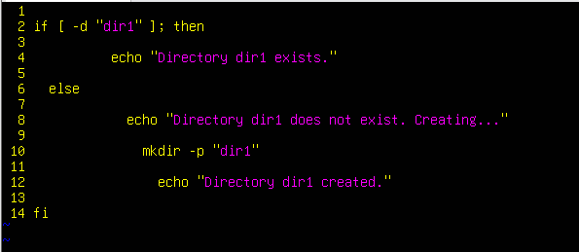
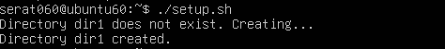
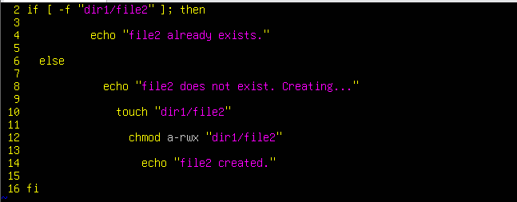
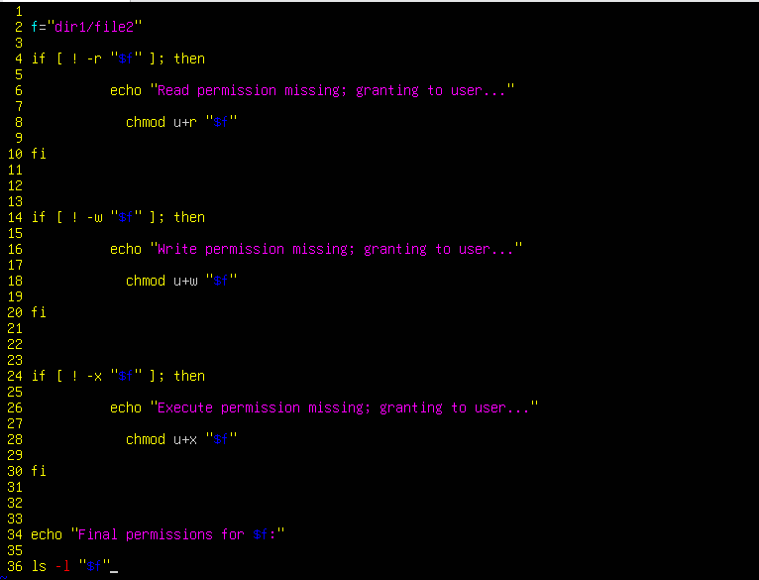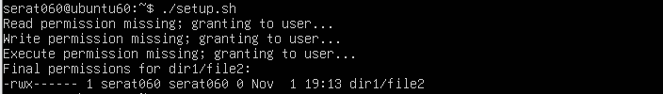

Task 11 – Script setup.sh – argument comparisons (eq, ne, gt, lt, ge, le) and string checks

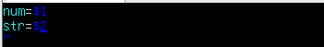
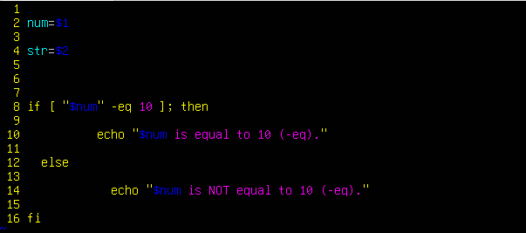
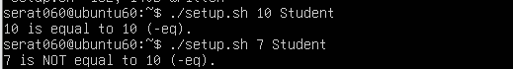
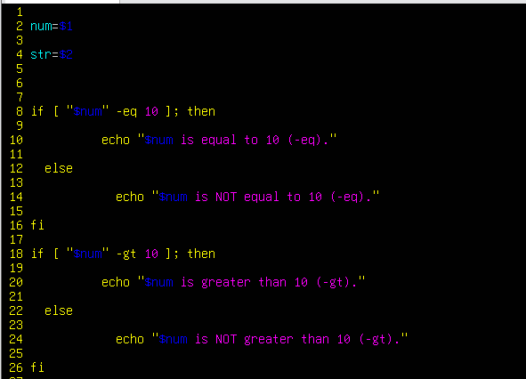
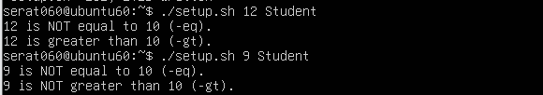
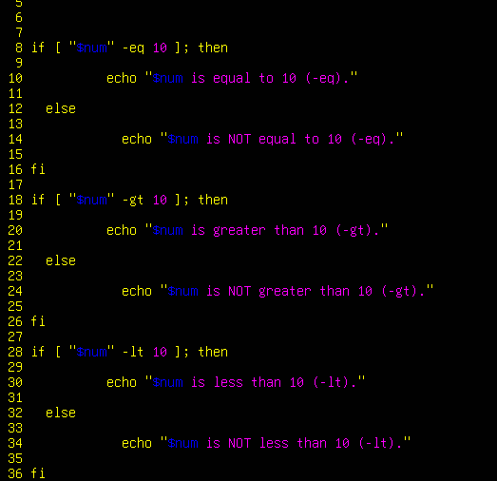
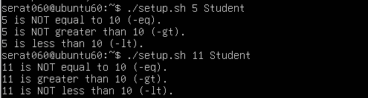
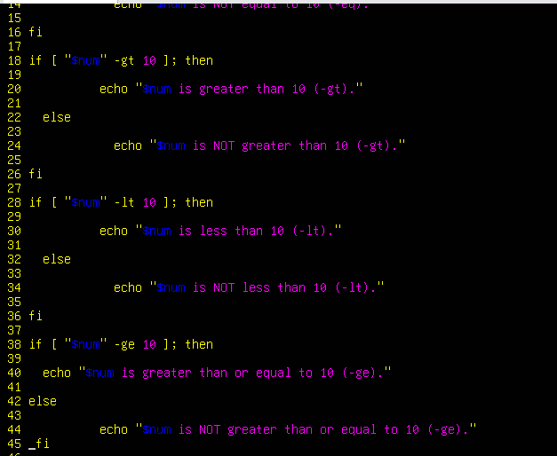
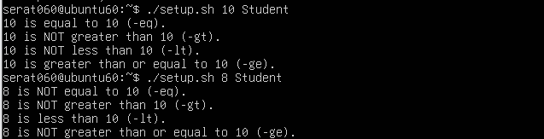
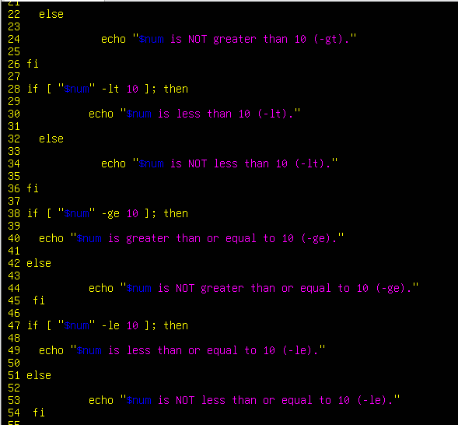
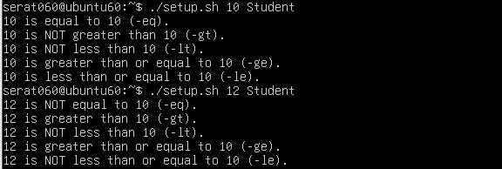
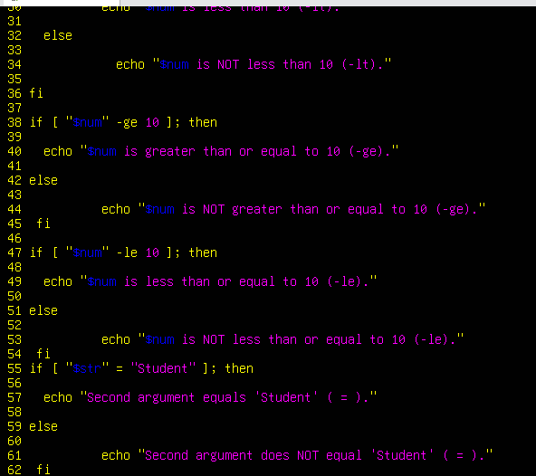
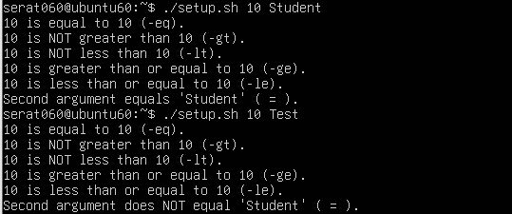
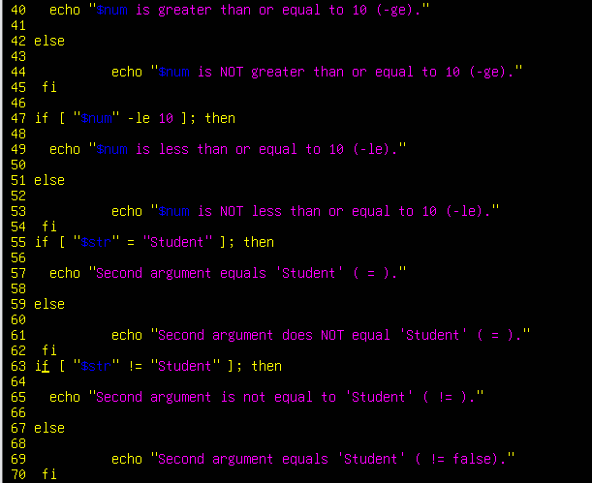
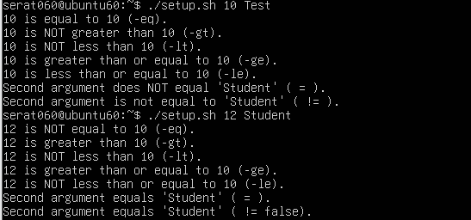
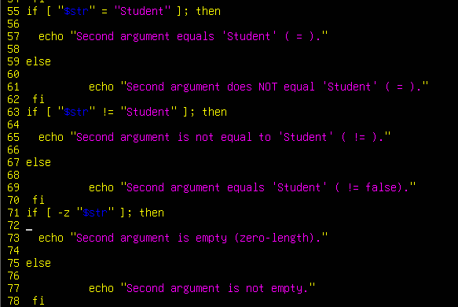
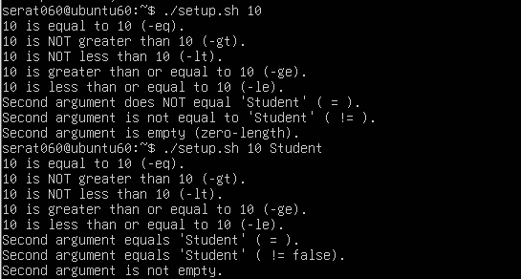

Task 12 – Script setup.sh – print all arguments with a for loop

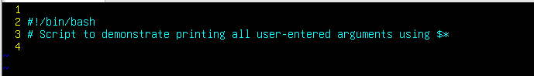
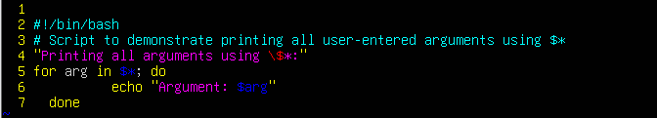
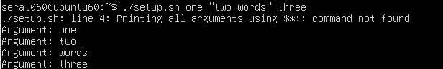

Task 13 – Script setup.sh – while loop summation and functions

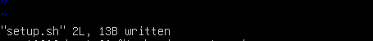
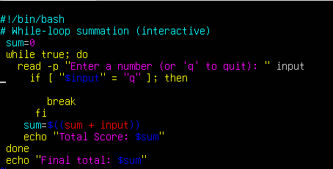
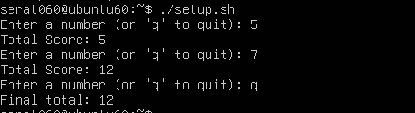
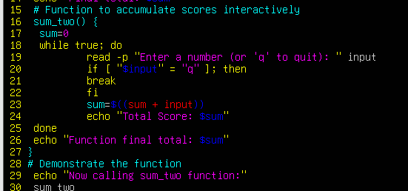
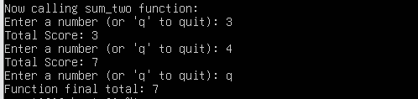
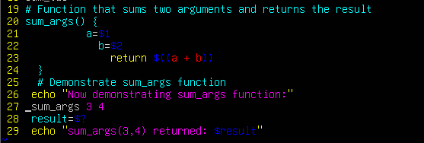
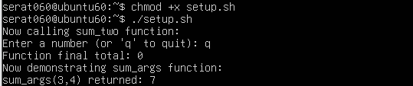
Task 14 – Codespaces GUI — fork repo, run start-desktop.sh, open VNC, stop GUI
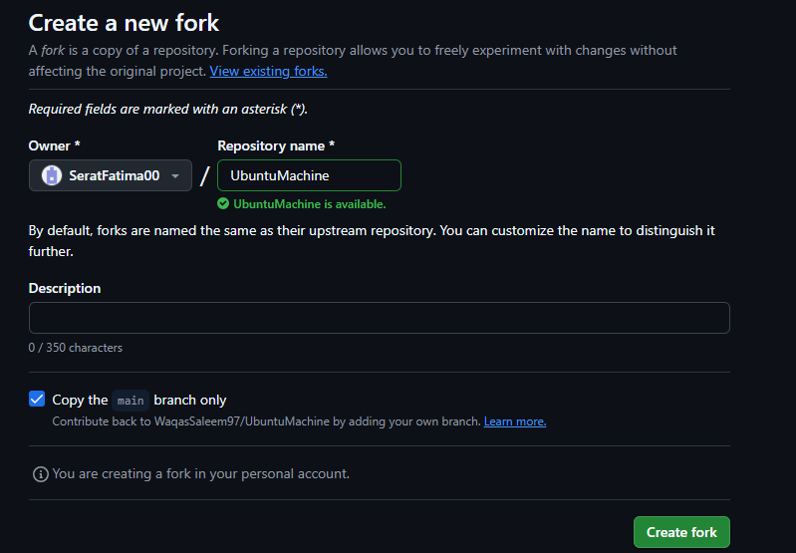
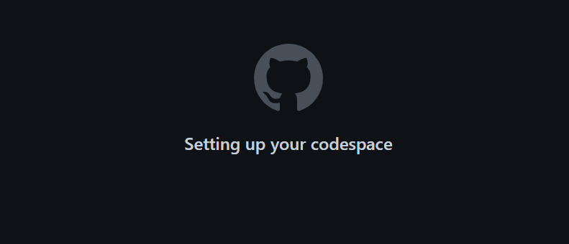
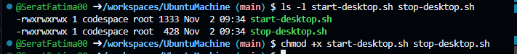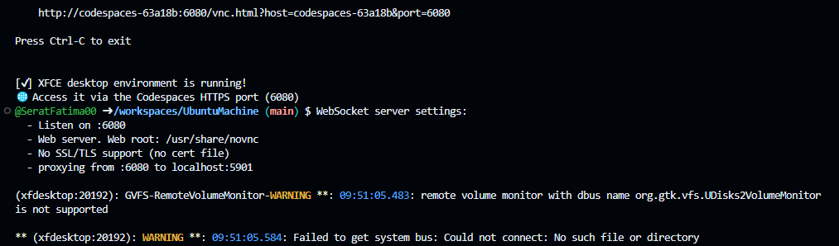
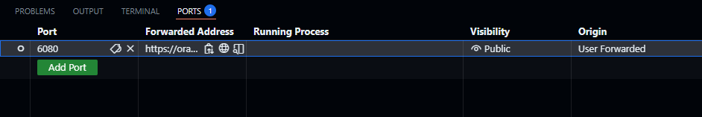
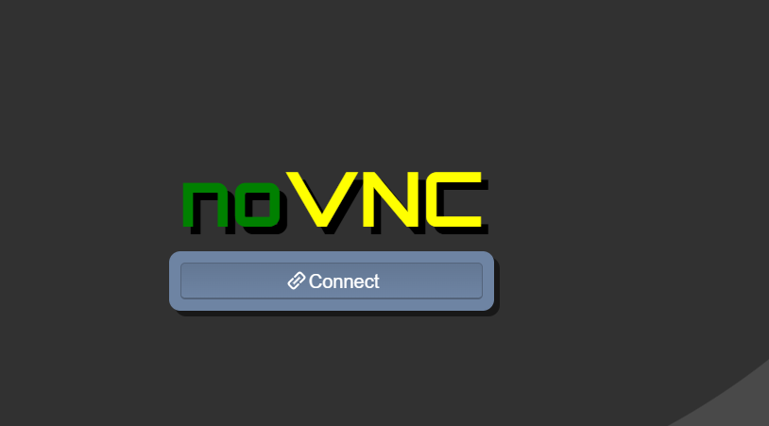
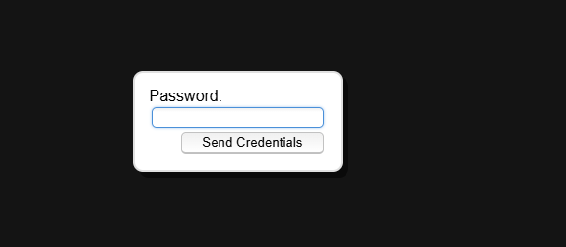
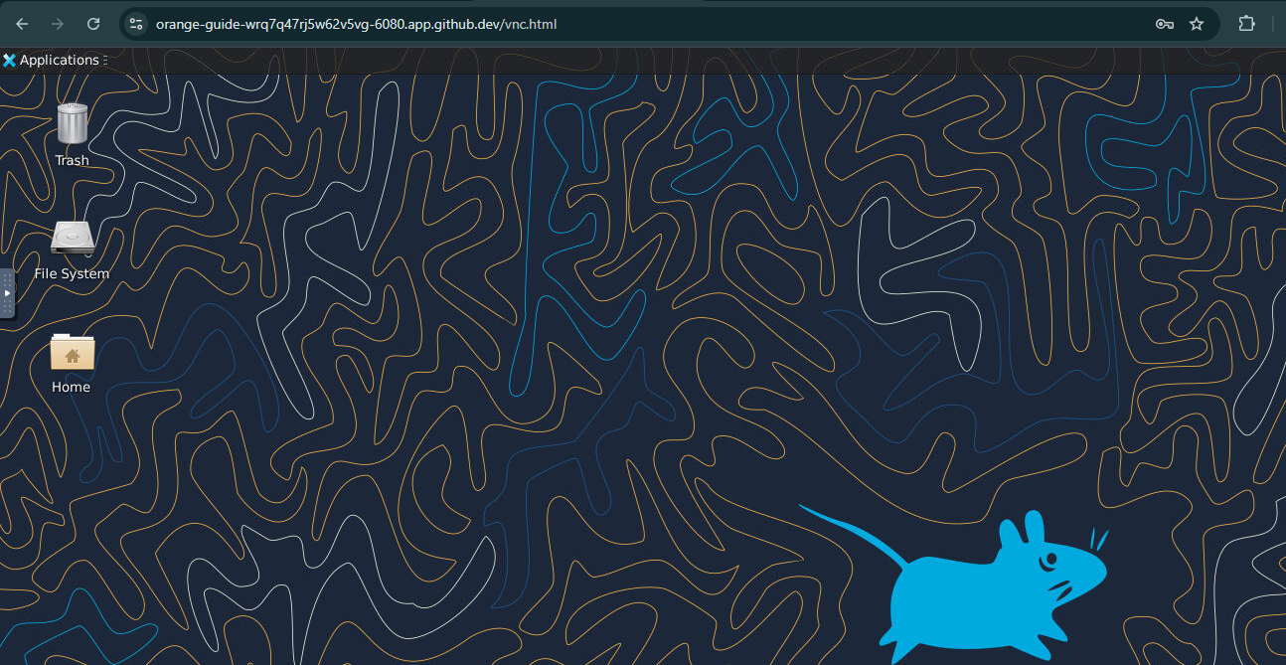
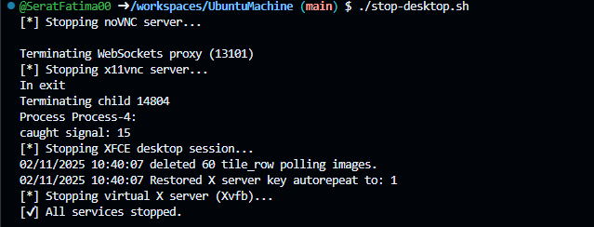
Exam Evaluation Questions

- Group Management and Membership

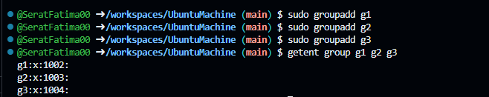
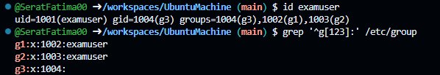
2. Ownership and Permission Tasks
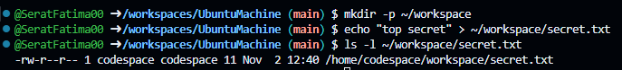
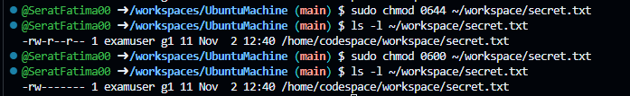

3. Pipes, Grep, and Redirection Practice

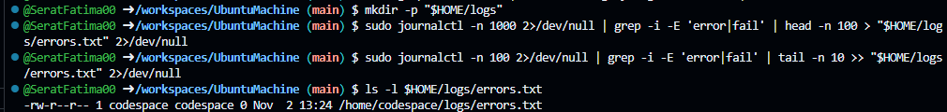


4. Script: Variables, Command Substitution, File & Dir Checks

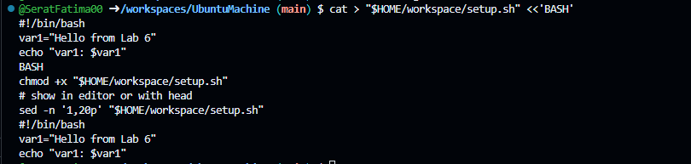
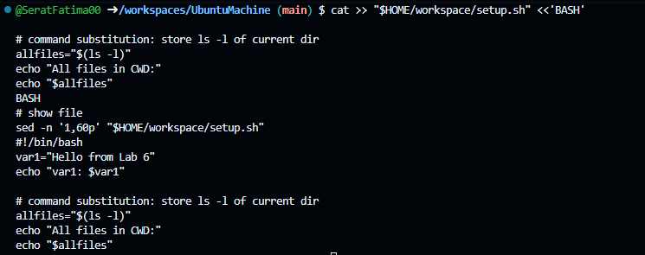
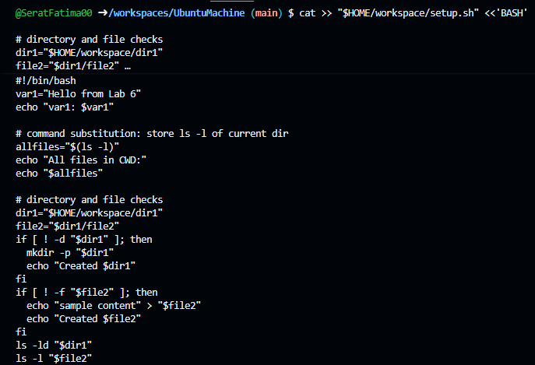
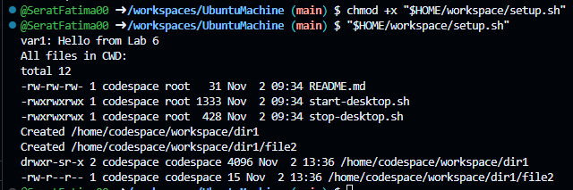

5. Script: Comparisons and String Tests

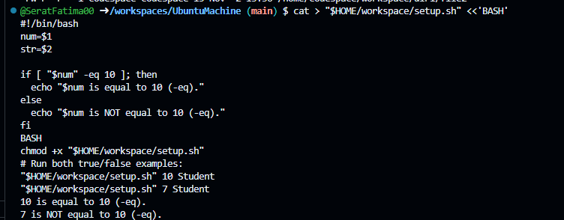
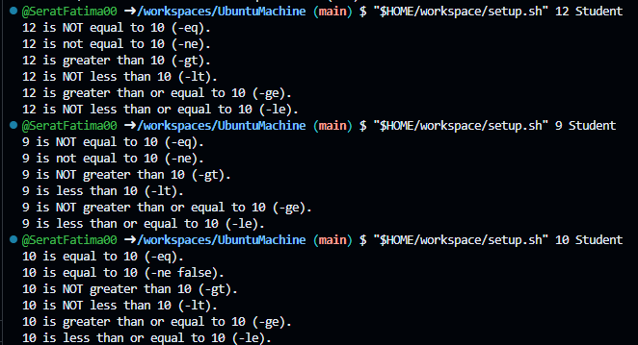
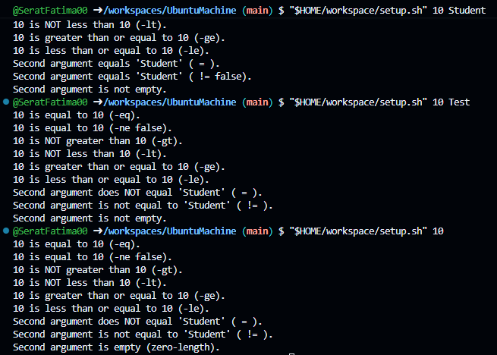

6. Script: For Loop and Argument Handling
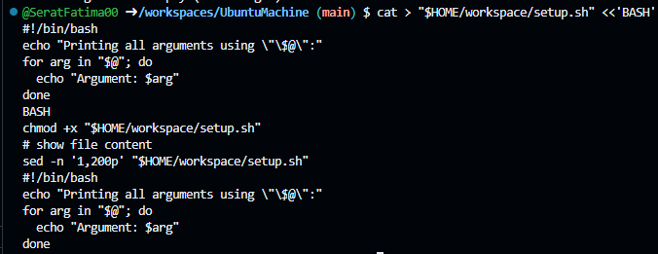
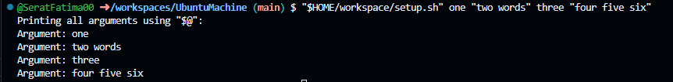

7. Script: While Loop Summation and Functions

